Capstone Project Report: Image Search using DETR Resnet50

Class : INFO-6147 Deep Learning with Pytorch
Professor : M. Yousefhussien
Program : AIM1
Student ID :1319840
Student Name : Edward (Seongmin Choi)

1. Abstract
This project implements an intelligent object detection and image retrieval system utilizing a DETR (Detection Transformer) model based on the Resnet50 backbone.
While the base model demonstrates excellent performance in classifying and locating objects on the standard COCO dataset, this study attempted to fine-tune the model to recognize a user-defined object called 'edodo'.
Although system integration was successful, the performance of detecting user-defined objects remains limited due to the significant time required for sample generation and model training.
To enhance user interaction, this system integrates Google Gemini, Huggingface, and Groq APIs to convert raw detection data into natural language reports.

2. Introduction
Modern computer vision has been revolutionized by Transformers. DETR simplifies the detection pipeline by removing the need for hand-crafted components like non-maximum suppression (NMS) or anchor generation. The goal of this capstone project is to:

- Deploy a robust object detection UI using Streamlit.
- Expand the model's capability to detect custom items ('edodo').
- Implement a fail-safe LLM reporting system that switches from Gemini to Groq upon token depletion.

3. Methodology

3.1 Model Architecture
- Base Model: facebook/detr-resnet-50.
- Customization: The final linear classification layer was modified to accommodate the new 'edodo' class (92 classes total).
- Pipeline: Images are preprocessed using standard Resnet50 normalization, passed through the Transformer encoder-decoder, and filtered by a confidence threshold (default: 0.5).

3.2 Intelligent Reporting Logic
To provide context-aware results, the system uses a dual-API strategy:

- Primary: Google Gemini Pro Vision analyzes the image and the list of detected objects.
- Secondary (Hugging Face + Groq Hybrid): * Hugging Face Integration: In cases where advanced image description is needed without relying solely on Gemini, the system can leverage vision-language models hosted on Hugging Face (e.g., BLIP or CLIP) to generate descriptive captions or verify specific target items.
- Fallback (Groq API): If Gemini tokens are exhausted or a service error occurs, the system automatically routes the textual detection metadata to the Groq API (utilizing Llama 3 or Mixtral). This ensures that the user still receives a descriptive, sentence-based report even when vision-specific APIs are unavailable.

3.3 DE⫶TR: End-to-End Object Detection with Transformers
1) DEtection TRansformer or DETR, are a set-based global loss that forces unique predictions via bipartite matching, and a transformer encoder-decoder architecture.

Given a fixed small set of learned object queries, DETR reasons about the relations of the objects and the global image context to directly output the final set of predictions in parallel.
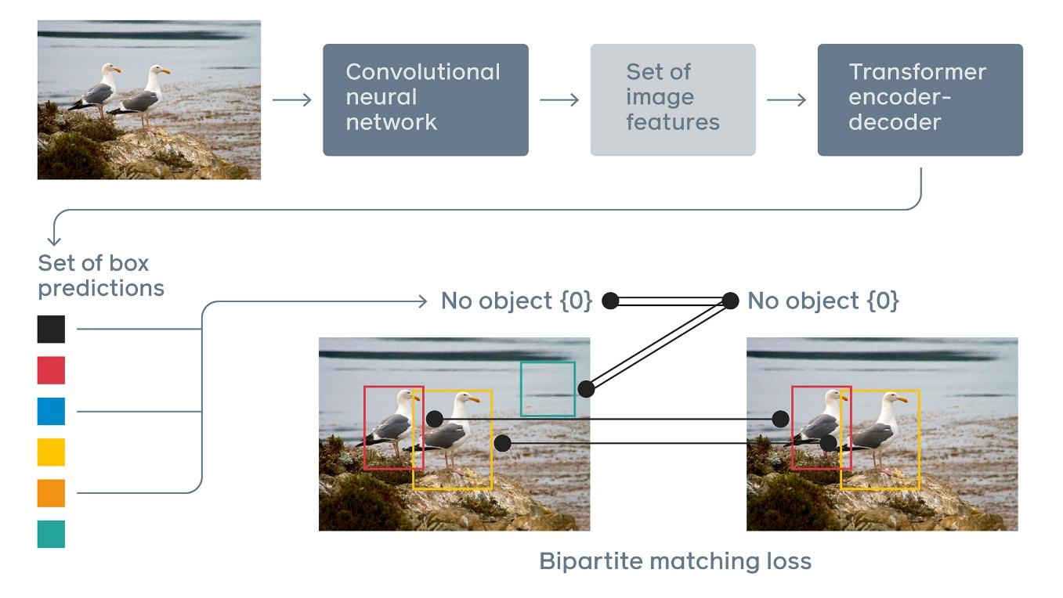
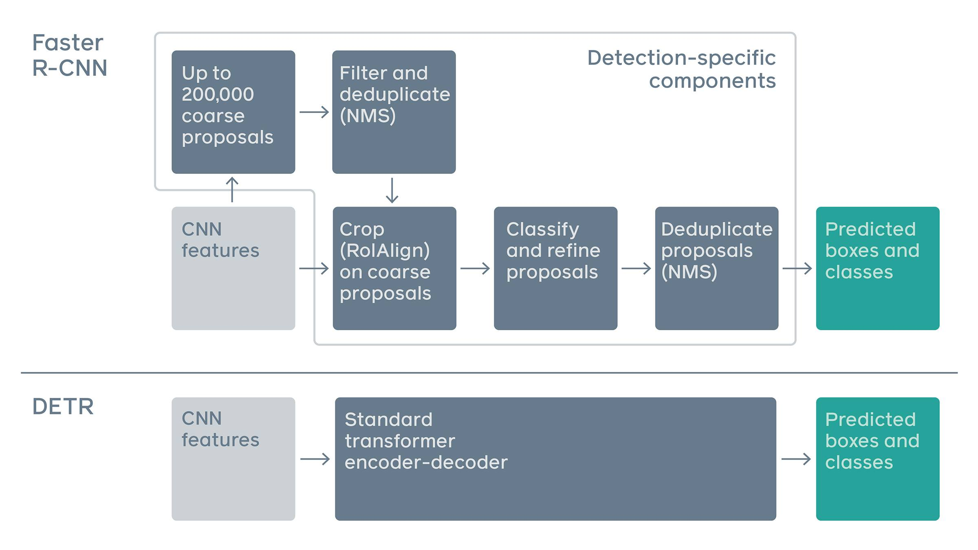
2) Related work
Their work build on prior work in several domains: bipartite matching losses for set prediction, encoder-decoder architectures based on the transformer, parallel decoding, and object detection methods.
3) DETR architecture
DETR contains three main components, which we describe below:
a CNN backbone to extract a compact feature representation, an encoder-decoder transformer, and a simple feed forward network (FFN) that makes the final detection prediction.
Inference code for DETR can be implemented in less than 50 lines in PyTorch.
4) Backbone
Starting from the initial image ximg ∈ R 3×H0×W0 (with 3 color channels2 ), a conventional CNN backbone generates a lower-resolution activation map f ∈ R ^{C×H×W} .
Typical values they use are C = 2048 and H, W = H0 /32 , W0 / 32 .
5) Transformer encoder.
6) Transformer decoder.
7) Prediction feed-forward networks(FFNs)
8) Auxiliary decoding losses.
They add prediction FFNs and Hungarian loss after each decoder layer. All predictions FFNs share their parameters. We use an additional

4. Results

4.1 Detection Performance
- Standard Objects: High precision and recall for people, cars, and household items.
- Custom Object ('edodo'): Currently suboptimal. The process of creating high-quality training samples and the actual training time proved to be major bottlenecks.

4.2 Statistics and Visualization
The system generates:

- Bounding Box Plots: Visual localization of all detected objects.
- Analysis Tables: Tabular data including object labels, confidence scores, and color indicators for UI clarity.

Object Class | Status | Notes
Standard COCO | Excellent | Fast and accurate
Custom (edodo) | In Progress | Requires more training data/time

5. Conclusion
The integration of DETR Resnet50 with multi-LLM support (Gemini, Hugging Face & Groq) successfully created a sophisticated image analysis tool. Although the 'edodo' custom detection requires further iterative training and a larger dataset to reach production-level accuracy, the methodology for API orchestration and model fine-tuning has been validated. Future research will focus on learning user-defined objects.

6. References & Links
- Model Source: Hugging Face DETR Resnet-50
- GitHub Link: https://github.com/edodo/DeepLearning

